1st Announcement for Lecture Course
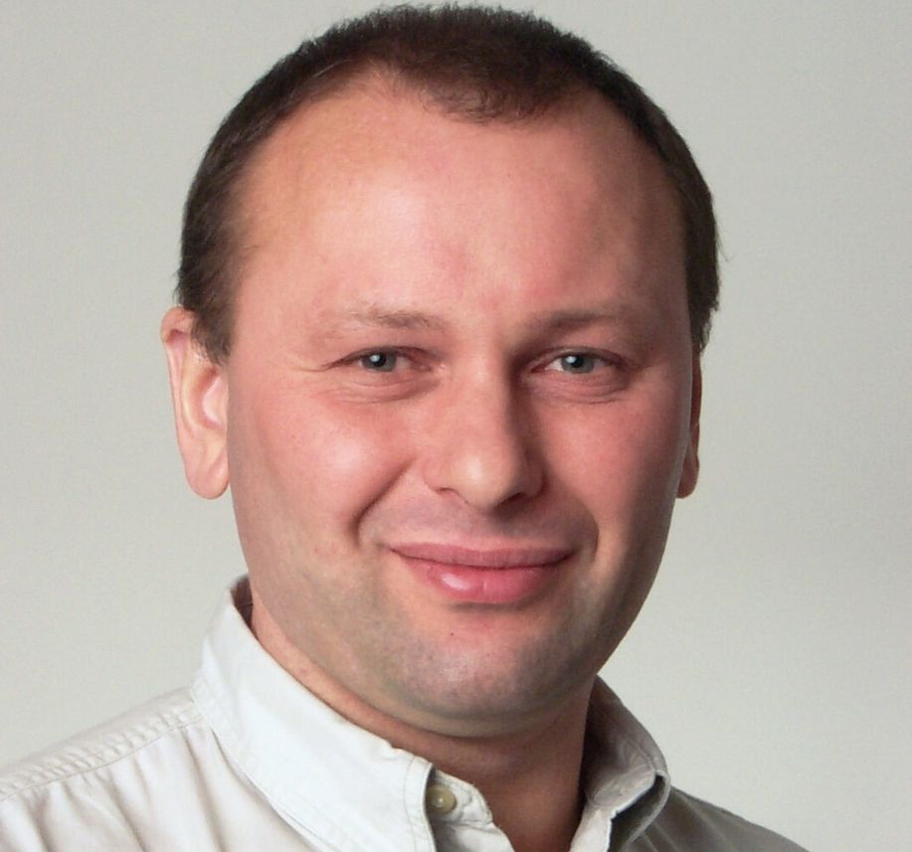
Isotope, Biomarker & Enzyme Applications
in Ecosystem Sciences
Prof. Dr. Yakov Kuzyakov
Scope: All master/PhD students and researchers interested in isotopes applications
Term: 16-18, June, 2016, 9:00 – 17:00 (2 days to the isotopes, 0.5 day to biomarkers and 0.5 to enzymes)
Place: Institute of Subtropical Agriculture (ISA), Chinese Academy of Sciences (CAS)
Registration: Dr. Zhenke Zhu (E-mail: isazzk@126.com; tel: 18175130837)
Ms. Hongzhen Jing (E-mail: jinghongzhen1987@126.com; tel: 18570628006)

The course will cover the following topics: (Extended information: www.uni-goettingen.de/en/123620.html)
- Introduction, Stable and radioactive isotopes, Tracers
- Labeling and natural abundance, Tracer approaches
- Analytics of stable and radioactive isotopes
- Applications of isotopes in soil – plant – relationships studies
  - C and N input by plants into the soil ¹⁴C, ¹³C, ¹⁵N, δ¹³C
  - C turnover and soil organic matter studies ¹⁴C, ¹³C, ¹⁵N, δ¹³C
  - Erosion estimation by isotopes ¹³⁷Cs, ²¹⁰Pb, ⁷Be
  - Autoradiography and imaging ¹⁴C, ³³P, ³²P, …
  - Isotope dilution method ¹⁵N
  - Bomb-¹⁴C ¹⁴C
  - Intra-molecular, compound-specific and bulk isotope patterns in C₃ and C₄ plants
  - Future developments: Coupling of isotopes with molecular biology and biomarkers
For more information about the course: www.uni-goettingen.de/en/123620.html
The course include also lectures to
- Biomarkers in soil science: Background, Analyses & Applications (held by Anna Gunina)
- Enzymes in soil microbiology: Background & Applications, Soil Zymography (held by Bahar Razavi)

Brief introduction of the speakers:
Dr. Yakov Kuzyakov’s research covers major areas in soil ecology and biogeochemistry, such as C sequestration, C/N turnover, CO₂ fluxes, nutrients, rhizosphere processes, priming effects, bio-degradation, etc. Applications of stable and radioactive isotopes.
Prof. Kuzyakov is Highly Cited Researcher, and published more than 200 referred journal papers.
He is on the Editorial Boards of European Journal of Soil Biology, Soil Biology & Biochemistry, Plant & Soil, and Journal of Plant Nutrition & Soil Science.
Prof. Kuzyakov have been working in Germany, Russia, China, USA, UK, Africa, and during 2014, he works as a visiting professor in the CAS, with Prof. Tida Ge as his host.
Anna Gunina apply isotopic approaches and biomarkers for analyses of C turnover and aggregate formation
Bahar Razavi use and develop methods of enzyme activities (including soil zymography) for microbial processes

Welcome all scientists interested in isotope, biomarker & enzyme applications!

